**NORTHFIELD COMMUNITY PRESCHOOL, PRIMARY, and ELEMENTARY SCHOOL**

**2000 New Road**

**Northfield, New Jersey 08225**

**609.407.4005**

[www.ncs-nj.org](http://northfield.groupfusion.net/)

**Mrs. Maureen Vaccaro**

**Elementary Principal**

[mvaccaro@ncs-nj.org](mailto:mvaccaro@ncs-nj.org)

September

Dear Parents/Guardians,

Every year, we have many children identified as having certain allergies. We all need to be sensitive and aware to the specific needs of our students. As an example, we have children in our school with allergies to latex, so we all need to understand that latex is found in many common everyday items, including balloons, banana skins, art supplies, kiwi, erasers, sneakers, and first aid materials.

We have made many strides in both our classrooms and our school to ensure a safe environment for all our children, and you can help with this endeavor in the following ways:

1. Remind your child to only use his/her school supplies, and never share with another classmate.

2. Never send balloons of any kind to school for any reason.

3. Do not allow your child to bring rubber stamps or stickers to school.

4. Latex is found in many soft, squishy plastics such as Koosh Balls, so please keep all soft plastic toys at home.

5. Children will never share snacks or any food items.

Many, many art supplies (including all Crayola products), first aid materials, and stickers, are safe, but some can be harmful. It is for this reason we are limiting all of it. Please contact me, or our Nurse’s Office, with any additional questions. **ALL items brought into a classroom must be vetted by the Homeroom Teacher and the School Nurse.**

We have and will continue to address this request often, and following these guidelines will help us have the most successful school year possible.

Thank you very much for your anticipated cooperation.

Sincerely,

Mrs. Maureen E. Vaccaro

Mrs. Maureen E. Vaccaro

Principal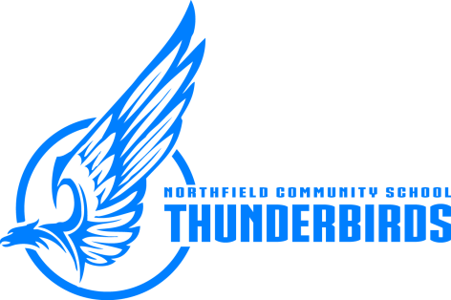

***Northfield Community School – “Children First”***

Equal Opportunity Employer