WHAT IS THE MCKINNEY-VENTO HOMELESS EDUCATION PROGRAM?

The McKinney-Vento Education for Homeless Children and Youth Program is a federally-funded program that provides supplemental instructional and support services for homeless children and youth, with the goal of enabling them to meet the same rigorous academic standards set for all children, despite the challenges encountered as a result of not having a permanent living situation. Becoming homeless is highly disruptive to students in many ways, manifested by school absences, changes of schools, difficulty in transferring school records, lack of adequate clothing, food, and shelter, anxiety and social/emotional issues, and even health related problems.

WHO’S MCKINNEY-VENTO ELIGIBLE?

School-aged children and youth and preschoolers who are currently without a fixed, regular or adequate night-time residence may qualify for program services, according to the program guidelines. Qualifying situations may include children residing in:

- Temporary shelters, including domestic violence and transitional living shelters

- Hotels and motels

- “Doubled-up” housing, where one family is living with another due to loss of housing stemming from financial problems

- Other public or private places not designed for or ordinarily used as a regular sleeping accommodation, such as abandoned buildings, cars, vans, camping areas, etc.

- Transitional housing for families

- Other special situations

We need your help in identifying
eligible homeless children. To make a referral, or for further information or assistance, please contact us at:

(856) 468-6530, ext. 1053
(856) 468-0851 FAX

Billie Danielle Thomas
Director
bthomas@gcecnj.org

Dalaine Wilson
Intervention/Resource Specialist
dwilson@gcecnj.org

Nichole Simmons-Graham
Intervention/Resource Specialist
nsimmonsgraham@gcecnj.org

Wanda Spraker
Health Specialist
wspraker@gcecnj.org

Janis Principato
Data Management Specialist jprincipato@gcecnj.org

Sonia Buehler
Program Manager
sbuehler@gcecnj.org

Stewart B. McKinney-Vento
Homeless Education
Program

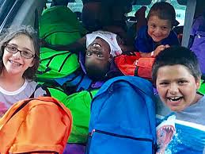

Operated by

Gloucester County Special Services School District
1340 Tanyard Road
Sewell, NJ 08080

AN OVERVIEW: REGIONAL MCKINNEY-VENTO PROJECT SERVICES Gloucester County Special Services School DISTRICT (GCSSSD)

Since January 1996, GCSSSD’s McKinney-Vento Project has provided supplemental services to more than 10,000 homeless children and youth in Gloucester, Camden, Atlantic and Burlington counties. Our primary objective is to help children and youth continue to maintain their academic levels while they are homeless, through supplemental tutoring and advocacy services. Several other related services are available as well.

- TUTORING
Supplemental tutoring is provided after school or sometimes during the school day, twice each week. Our tutors assist students with their homework assignments, reinforce basic skills, and address problem skill areas. They also focus on study skills and organizational skills. In addition, they incorporate esteem-building activities into the tutoring sessions and often act as mentors. This is our most requested service.

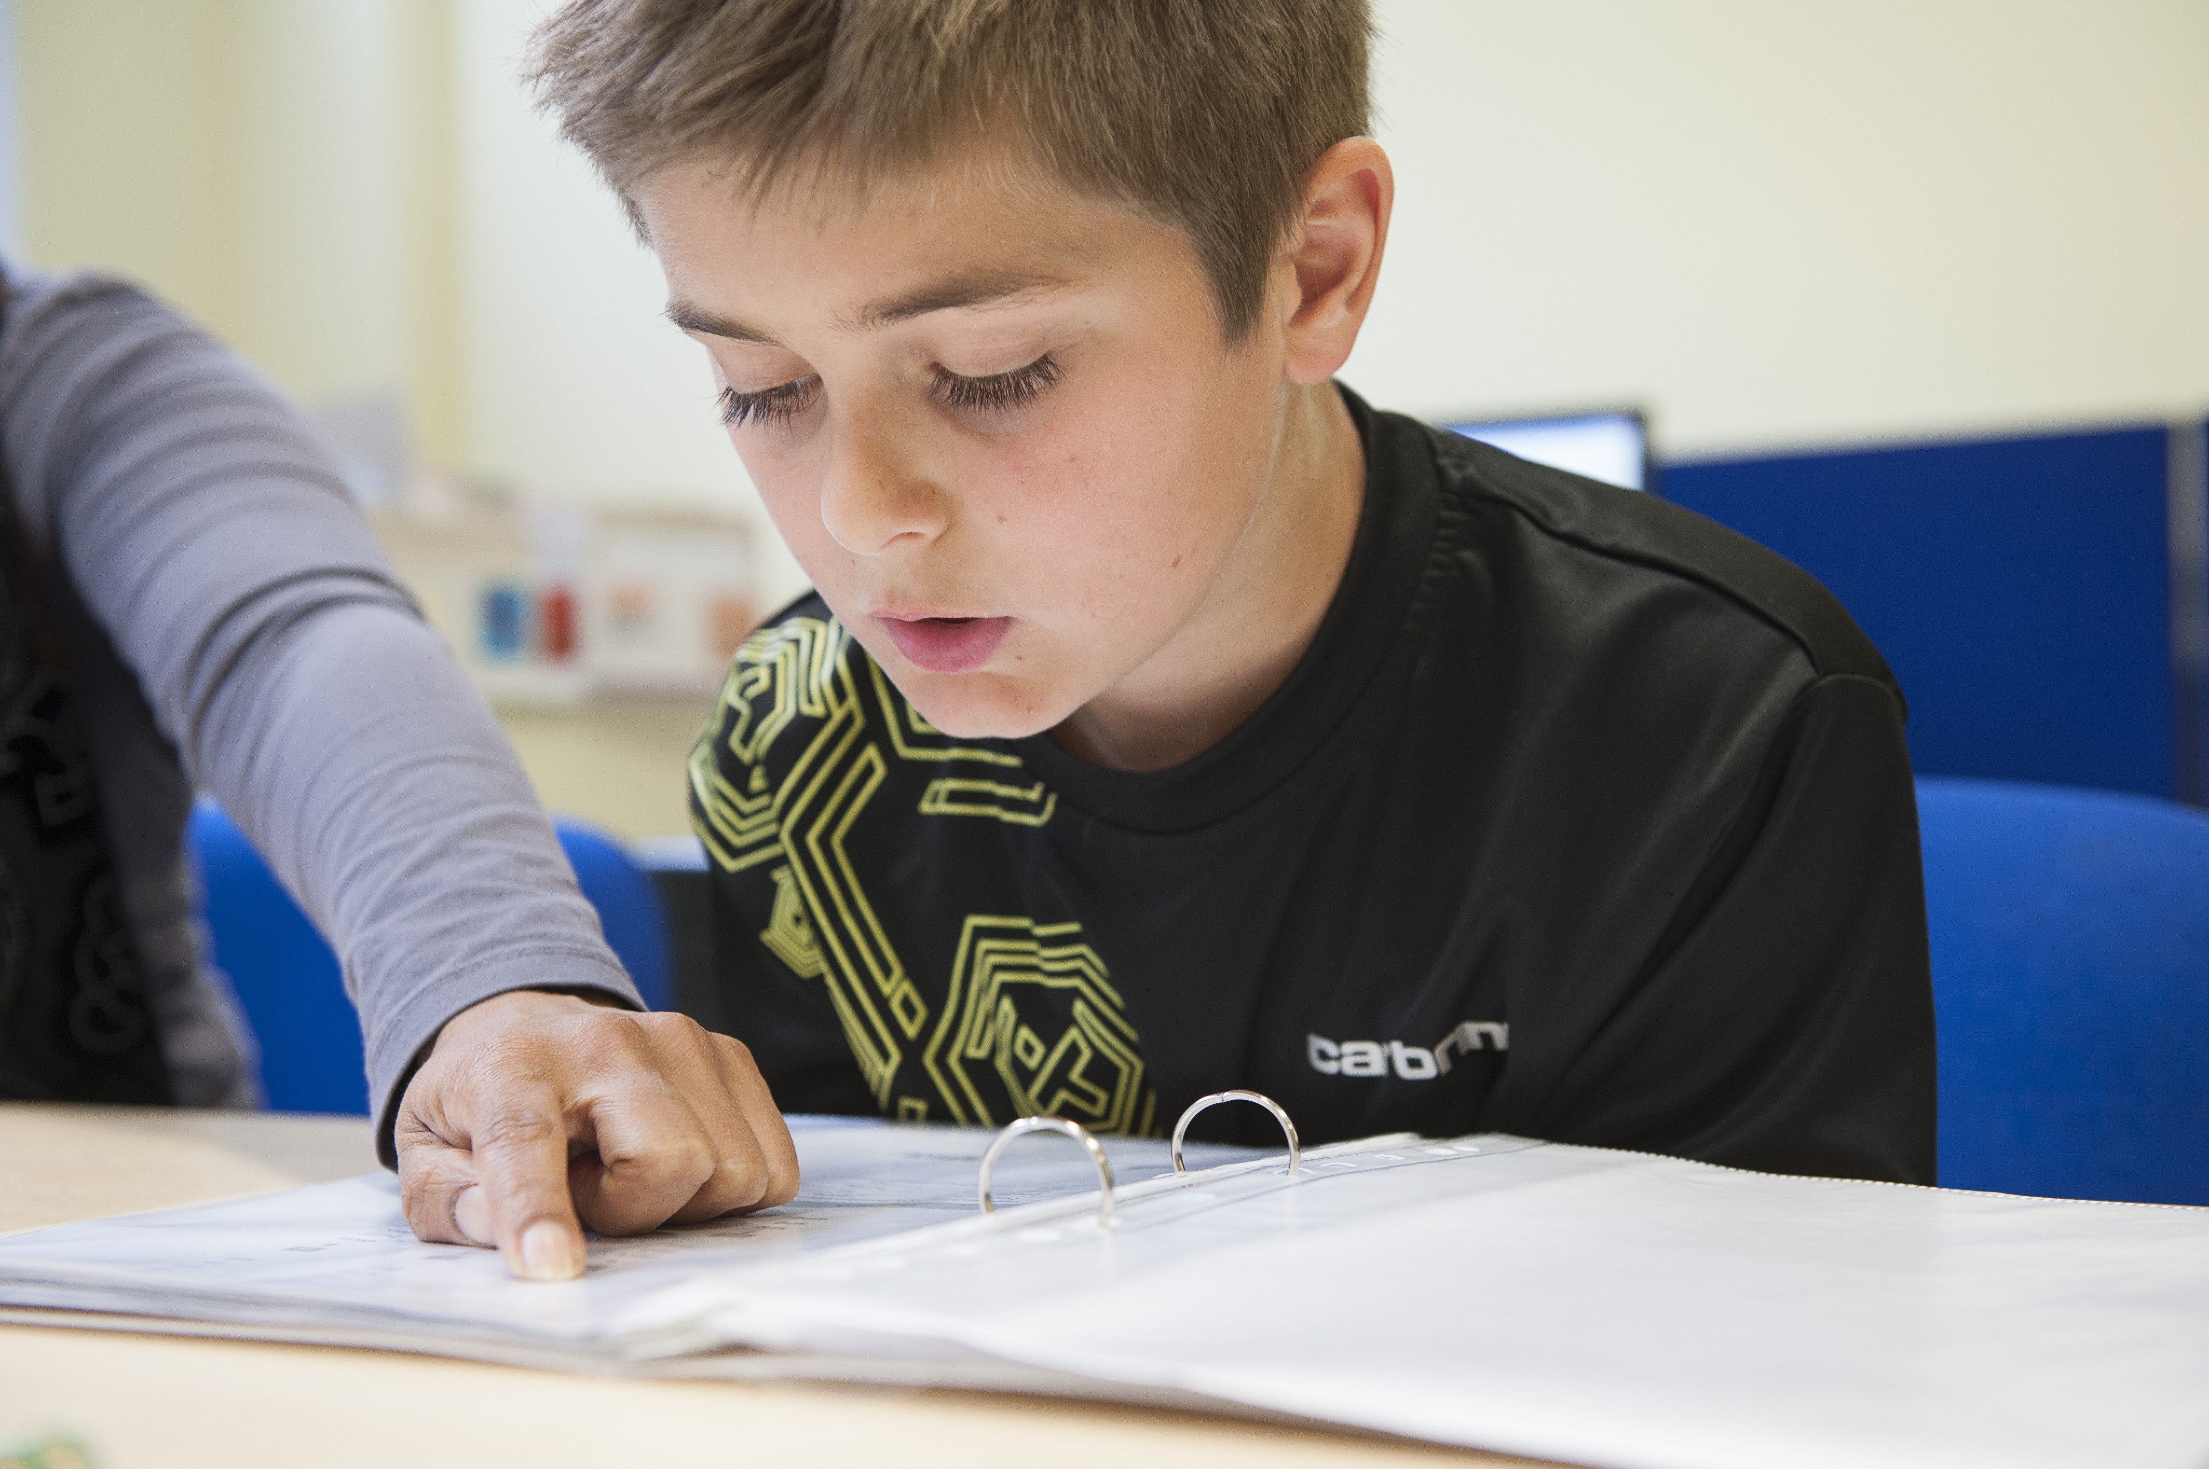

- ADVOCACY
Assistance is offered to both parents and school districts to ensure that homeless students are in the appropriate classes and grade levels and are receiving the services available to them. Resources and referrals are made available as needed, including having Intervention Resource Specialists accompany parents/guardians to a conference or meeting.

- SCHOOL SUPPLIES
Homeless children participating in our program are furnished with all the school supplies they need – from backpacks & lunch boxes to paper, pencils and calculators.
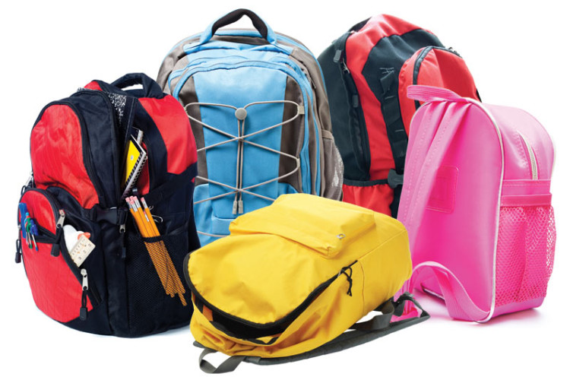

- COUNSELING
Weekly counseling sessions are provided, usually in group sessions. Topics may include anger management, dealing with grief, peer pressure, self-esteem, goal setting, etc. One-on-one counseling and individual family counseling are also provided on an as-needed basis.

- SUPPLEMENTAL TRANSPORTATION
Supplemental transportation services to/from school are provided for a brief period while districts are making their own arrangements.
When no other resource is available, after-school transportation is arranged and provided to homeless children who want to participate in sports and other extracurricular activities. This helps ensure integration with their non-homeless peers.



- AWARENESS SESSIONS
To raise awareness of and sensitivity to the unique needs of homeless students, the project periodically schedules workshop sessions with a variety of school personnel throughout the county, including teachers, guidance staff, social workers, nurses, secretaries and district homeless liaisons. Sessions are held countywide or can be arranged for individual districts or schools.

- HEALTH SERVICES
Upon the identified need, our McKinney-Vento Intervention Resource Specialists assist with scheduling appointments for health services such as immunizations, eye exams, eyeglasses and dental exams. We can also coordinate to provide transportation to and from these appointments. When necessary, we can assist with service payment.



- PARENT ACTIVITIES
Several times each year we schedule parent workshops for the homeless parents involved in our program. A variety of topics are presented, such as stress management, role modeling, health issues, the importance of encouraging your child to read, and being involved in your child’s education. We also provide dinner, babysitting, books for both children and adults, and door prizes. In addition, we encourage parents to get involved in their children’s weekly tutoring sessions and their education in general.

